Professional Portfolio Website
Project Document

Week 1: Planning, Content & SAD Diagrams
1. Project Overview
1.1 Problem Statement

Early-career students and job-seekers often struggle to present their technical skills, academic background, and project work credibly to prospective employers. Traditional static resumes (PDFs)and scattered social profiles fail to showcase project depth (such as live visual demos,comprehensive write-ups, or clean source code) and do not provide a single consolidated professional brand entry point for recruiters. This project directly addresses that gap by producing apersonal, mobile-responsive, always-available portfolio website.

Gather Content: Prepare my details
• Student Name: Tharuka Tharindu
• Role / Title: ICT Undergraduate & Aspiring Front-End / UI-UX Developer
• Project Name: Personal Professional Portfolio Website
• Primary Objective: To design, develop, and publish a responsive personal portfolio website that highlights my academic background, technical skills, and practical projects for future internships and career opportunities

2. Portfolio Structure & Content Plan
Home & About Me: Short bio, title (e.g., Full-Stack Developer / ICT Student), career objectives
• Professional Title: ICT Undergraduate | UI/UX & Web Developer
• Short Bio: Hi, I’m Tharuka Tharindu! I am a passionate ICT undergraduate with a strong foundation in IT fundamentals and web development. I enjoy turning ideas into visually appealing designs and working code.
• Career Objectives: To secure an internship in software development or UI/UX design where I can apply my web development, programming, and design skills to solve real-world problems while growing professionally.
Education & Skills: Degree details, technical skills (Java, C#, SQL, HTML, CSS), and soft skills.

Education
- G.C.E. Ordinary Level (O/L): Successfully Passed
- G.C.E. Advanced Level (A/L): Successfully Passed
- Current Qualification: Bachelor of Science in Information and Communication Technology (ICT) Undergraduate

Technical & Soft Skills
- Design & Prototyping: Figma, Adobe Photoshop
- Web Technologies: HTML5, CSS3
- Programming Languages: Java ,c++,c#
- Soft Skills: Problem-solving, creative design, time management, continuous learning
Projects

Project 1: Scientific Calculator Design
- Problem Statement: Standard basic calculators lack a clean, modern user interface for complex calculations.
- Contribution: Designed and structured the UI layout and functional buttons for a user-friendly calculator interface.
- Tools & Technologies: Figma, HTML, CSS
Project 2: Obstacle Avoidance Game
• Problem Statement: Creating a basic interactive logic game to practice object collision and logic flow.
• Contribution: Built the core game mechanics and player controls to navigate around moving obstacles.
• Tools & Technologies: Java
Project 3: Wireframe UI/UX Design
• Problem Statement: Creating realistic web and mobile layout wireframes before full development.
• Contribution: Designed complete desktop and mobile user interfaces, focusing on user flow and accessibility.
• Tools & Technologies: Figma

Day 02

Executive Summary
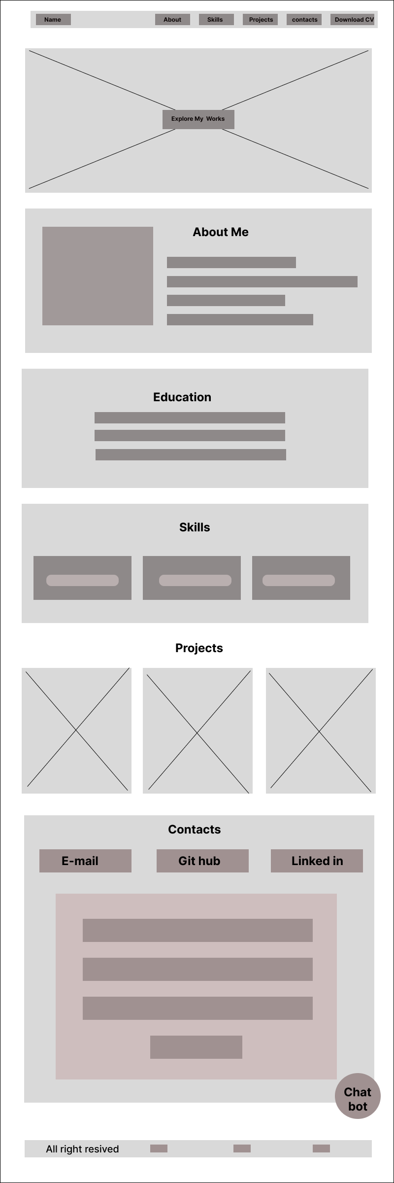
Today, I began the System Analysis and Design (SAD) and development process for my professional portfolio website. The primary objectives for today were to finalize the visual layout plan for the homepage and implement the first functional section of the website using HTML. Both objectives were successfully achieved. This report details the design principles applied during the wireframing phase and the technical implementation of the navigation bar.

Implementation Phase: Navigation Bar Development
Following the design stage, the implementation phase was initiated, focusing specifically on developing the portfolio’s navigation bar. The objective was to translate the conceptual design into a functional, coded component.
Technical Stack & Methodology
The navigation bar was constructed using a modern front-end technical stack to ensure structural integrity and a professional user interface:
- HTML (HyperText Markup Language): Used to establish the semantic structure and content framework of the header.
- CSS (Cascading Style Sheets): Employed for professional visual design, managing layout, positioning, and stylistic elements.
- JS (JavaScript): Implemented to integrate dynamic behavior and interactivity, enhancing overall user engagement.

Day 03
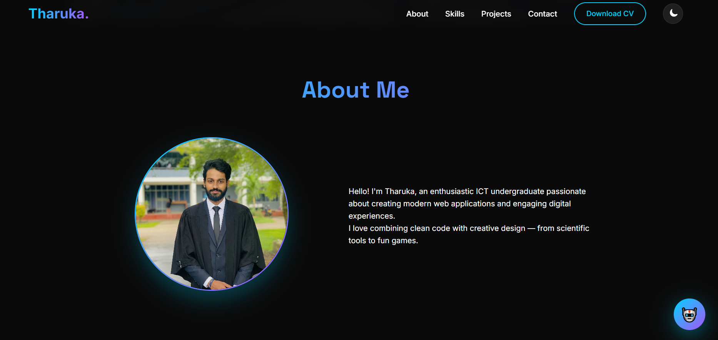

Today marked the third day of the development phase for my professional portfolio website. The primary focus was the design and implementation of the "About Me" section, translating previous wireframe concepts into functional code. Additionally, an advanced interactive feature, a fixed Chatbot Interface, was successfully developed and integrated onto the homepage. Both objectives were achieved, significantly enhancing the visual appeal and user engagement of the site.

2. Implementation Phase: The "About Me" Section
The objective of today's main task was to build a visually striking and professionally structured "About Me" segment that effectively communicates my background and passions.
Creative and Technical Implementation
• Dark-Theme Aesthetic: The section maintains the overall dark aesthetic, utilizing a solid black background. The typography is standardized with a distinct "About Me" header in a lighter shade for clear visibility and consistent branding with the rest of the site.
• Circular Profile Image: A key visual feature is the circular profile picture. I implemented this using CSS to crop and frame my professional photograph, creating a modern, focused appearance.
• Structured Content: I implemented the text section using semantic HTML, providing a narrative introduction about my role as an enthusiastic ICT undergraduate. This description was paired and aligned with the image for a balanced layout.

Information Gathering & Asset Deployment
To achieve the desired professional look and interactivity for today’s deliverables, I conducted targeted research and self-study using several key technical resources.
- CSS Framing & Styling: I utilized [ Resource Name, e.g., W3Schools/YouTube Channel] to learn advanced CSS properties for creating perfect circles (border-radius) and precise positioning of images. This resource provided step-by-step examples that I adapted for my specific layout.
- Layout Alignment: To align the circular image perfectly alongside the bio-text, I referenced best practices for CSS Flexbox on [ Resource Name, e.g., MDN Web Docs/Flexbox Froggy]. This allowed me to create a responsive and clean side-by-side structure that adjusts effectively to different screen sizes.
- Semantics & Structure: The overall HTML structure was built by reviewing semantic markup tutorials on [ Resource Name, e.g., FreeCodeCamp/W3Schools], ensuring the page is accessible and easily parsed by search engines.

Day 04
1. Executive Summary So, today was Day 4 of getting my portfolio site built, and my main focus was finally tackling the "My Skills" section. I wanted to take the rough wireframes we had and turn them into something visual, dynamic, and actually engaging. I had a few annoying setbacks with CSS along the way, but I managed to push through and get everything working exactly how I envisioned. Here’s a rundown of what I did and how I fixed the problems that popped up.
2. Implementation Phase: The "My Skills" Section The goal for today was simple but tough: create a polished, professional section that shows recruiters exactly what I can do. It had to be easy to read and intuitive, but it also needed to match the modern, dark theme of the rest of the site.
How I Built It:
- A Modular Grid: I wanted the skills to look good on any screen size—whether it's a huge monitor or a phone. So, I used a flexible grid layout. I wrapped each skill inside its own separate "card" (a dark grey box with soft, rounded corners). This keeps everything neat, organized, and modular.
- Matching the Vibe: The background matches the site’s dark theme perfectly. For the title, "My Skills," I went with a clean, standardized font and used that vibrant gradient/cyan-white look to make it stand out.
- The Data: For now, I set the proficiency levels as static percentages for my main tech skills
  - HTML / CSS / JavaScript: 92%
  - C++ / C# / Java: 85%
  - UI/UX Design (Figma): 88%
3. Targeted Technical Challenges & Problem Solving As usual, the development didn't go completely smoothly. I hit a few specific technical snags that were tough to solve.
Challenge 1: Getting the Gradient Progress Bars to WorkThe Problem: The design required the progress bars to have a unique, dynamic look—specifically, a linear-gradient fill that changes from deep blue to purple, not just a flat, solid color. The issue is that the standard HTML <progress> element doesn't really let you use gradients by default.
The Solution: I finally figured out that trying to force the native progress element to do what I wanted was a dead end. Instead, I just custom-built them from scratch using nested divs.
- I made an outer div to be the dark background (the "empty" bar).
- Then, I put a child div inside it and used CSS to set its width based on my percentage.
- The key step was applying that linear gradient as the background-image for the child div. It took a bit of Googling and forum research to find the right syntax, but once I did, I had total cross-browser control over the look.
Challenge 2: Keeping the Numbers Synchronized with the BarsThe Problem: My design had the skill name and the numeric percentage displayed right next to each other, but the width of the bar below it also had to change. If I update one of those numbers in the future, how do I make sure I don't forget to update the other one? This was a maintenance nightmare waiting to happen.
The Solution: I used smarter, "semantic" CSS naming conventions. I separated the whole thing into a clear hierarchy in the HTML:
- A "Header" div that only holds the name and percentage.
- A separate "Bar" div below it. By structuring the CSS this way, I ensured that the percentage text is prioritized (for human readers and robots), while the bar just reflects the exact width needed. It makes the section much easier to maintain manually later.
Challenge 3: Fixing the Responsive Layout on MobileThe Problem: The desktop version looked great with all three cards side-by-side. But on a smaller mobile screen, they would just shrink down unprofessionally, making the text unreadable.
The Solution: I had to jump into CSS Media Queries. By setting a breakpoint (like < 768px), I forced the grid to wrap the items automatically. So, on a desktop, it’s a neat row of three, but on a phone, it automatically switches to a stacked, single-column layout. This guarantees everything remains readable and fits the screen.
4. Achieved Technical Milestones
- Finalized "My Skills": The whole section is built, operational, and looks exactly how I wanted it to—polished, professional, and matching the dark theme.
- Mastered the Gradient CSS: I’m pretty proud of how I got the complex gradient effect working by building my own custom divs, rather than fighting with the native elements.
- Adaptive on All Screens: The Media Queries are working perfectly, so I know the site looks great on both mobile and desktop.
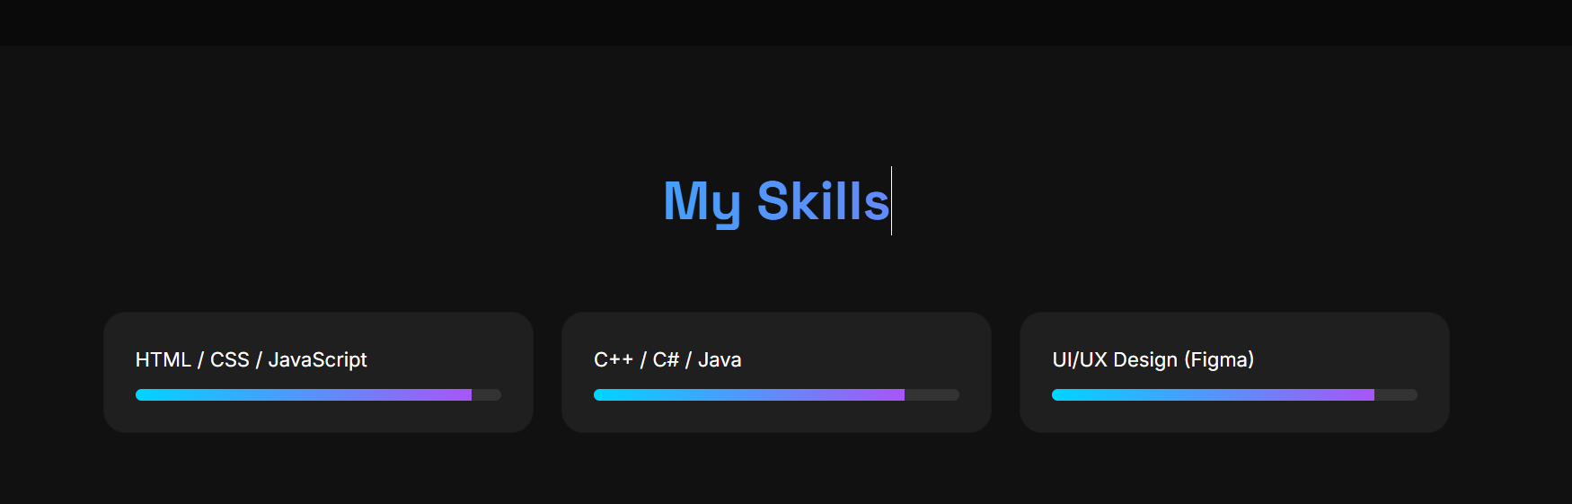

Day 05
Today marked the sixth day of the development phase for my professional portfolio website. Following the completion of the foundational "About Me" and "Skills" sections, the primary focus for today was moving into the core showcase of the site: the Featured Projects section.
The main objective for Day 6 was to implement the HTML (HyperText Markup Language) structure for this entire section. This involved creating the semantic framework needed to display multiple distinct project case studies effectively, including titles, descriptions, images, and links. This objective was successfully achieved, providing a solid, organized base for tomorrow's styling phase.

implementation Phase: Featured Projects (HTML Structure)
The goal of today’s task was to build the underlying architecture of the project section, ensuring it can dynamically and neatly present information about specific technical works.
HTML Technical Execution:
- Semantic Section Container: Using modern semantic standards, I implemented a main <section> element with a unique identifier (e.g., id="projects"). This allows for direct linking from the navigation bar and logical separation of content.
- Modular Project Cards: To ensure scalability and ease of maintenance, I designed a modular structure. Each project is encapsulated within its own dedicated container (div with a standard class, e.g., class="project-card"). This approach means adding a new project is as simple as copying and pasting this template structure.
- Rich Content Placeholders: Within each modular card, I established semantic placeholders for key project components:
  - <h3> tags for standard Project Titles (e.g., "Scientific Calculator").
  - <p> tags for concise Project Descriptions (e.g., "Advanced calculator with scientific functions.").
  - <img> tags for standard Project Images/Thumbnails (using placeholders or sample URLs for now).
  - <a> (anchor) tags for linking to live demos or external repositories.
- Structured Information Block: Following the initial wireframe conceptualization, I finalized the content hierarchy within each card. The structure groups the title and description logically alongside or near the image placeholder to provide an instant overview.

Challenge : Ensuring Semantic Adequacy and Accessibility (SEO-Friendly)
The Problem: It is common in HTML development to rely heavily on generic div tags for everything. However, a truly professional portfolio must be accessible to assistive technologies (screen readers) and optimized for search engine optimization (SEO). Using a non-semantic structure would violate these critical requirements.
The Solution: I resolved this by committing to modern semantic markup. I carefully selected appropriate tags rather than generic alternatives. I used the <section> tag to define the entire area, rather than just a div. I used <h3> tags for project titles to establish a correct heading hierarchy (SEO best practice), ensuring they follow logically after the main <h2> section title. By avoiding excessive nesting, I created a cleaner, more accessible structure.

Day 06
Today marked the seventh day of development for my professional portfolio website. Building directly on top of the HTML structure established on Day 6 for the Featured Projects section, the primary objective for Day 7 was to implement the visual design, interactive animations, and JavaScript logic.
Using custom CSS3 and vanilla JavaScript, I transformed the static project markup into an interactive, visually engaging showcase featuring smooth hover states, responsive dynamic layouts, image zoom effects, and clickable navigation handling. All core objectives for this section are now fully operational.

2. Implementation Phase: Featured Projects (CSS Styling & JavaScript)
CSS Styling Execution:
- CSS Custom Properties (Design Tokens): Maintained design consistency across the theme by leveraging global CSS root variables (--primary: #00d4ff, --accent: #a855f7, --card-bg: #1f1f1f, etc.).
- Gradient Typography: Styled the section title (<h2>) with a modern linear gradient text effect (linear-gradient(90deg, var(--primary), var(--accent))) utilizing -webkit-background-clip: text.
- Responsive Grid System: Implemented CSS Grid using repeat(auto-fit, minmax(320px, 1fr)) with a 25px gap. This allows project cards to automatically wrap and resize down to 320px mobile viewports without needing rigid media query breakpoints.
- Interactive Project Cards: Styled .project-card elements with rounded corners (border-radius: 20px), subtle borders (--border-soft), and dynamic transform transitions (transition: all 0.4s ease). On hover, cards smoothly elevate upward (translateY(-12px)) and display a glowing accent box-shadow (rgba(168, 85, 247, 0.25)).
- Image Hover Micro-Interactions: Applied object-fit: cover to project images for clean aspect ratio preservation, along with a subtle scale transformation (transform: scale(1.08)) on card hover.
- Button & Tag Styling: Added customized pill-shaped buttons (border-radius: 50px) for project actions, including distinct styling for Figma project links (.btn-figma with #10b981 accent background).
JavaScript Logic Execution:
- Dynamic Card Click Handler: Implemented an event listener attached to .project-card elements that contain a data-link attribute.
- Tab-Safe Navigation: When a user clicks anywhere on a card, the script extracts the URL from card.dataset.link and opens the target destination in a new browser tab (window.open(targetUrl, '_blank')).

3. Technical Challenges & Problem Solving

Challenge 1: Preventing Image Overflow During Scale Animations
The Problem: When applying the zoom effect (transform: scale(1.08)) to project images on hover, the enlarged image burst out of the card container's rounded corners, breaking the card's visual boundary.
The Solution: Resolved this by explicitly declaring overflow: hidden on the parent .project-card styling rules. This forces child elements (including scaling images) to clip neatly inside the card's 20px border radius during transition animations.

Challenge 2: Card-Level Clickability vs. Specific Internal Button Links
The Problem: Making an entire card clickable using JavaScript could potentially conflict with nested buttons inside the card or accidentally trigger unexpected navigations if a project card is missing a destination link.
The Solution: Used target-specific dataset queries (document.querySelectorAll('.project-card[data-link]')). By filtering the event listener setup to only run on cards explicitly assigned a data-link attribute, non-linked cards remain static while valid projects navigate cleanly in a new window (_blank).
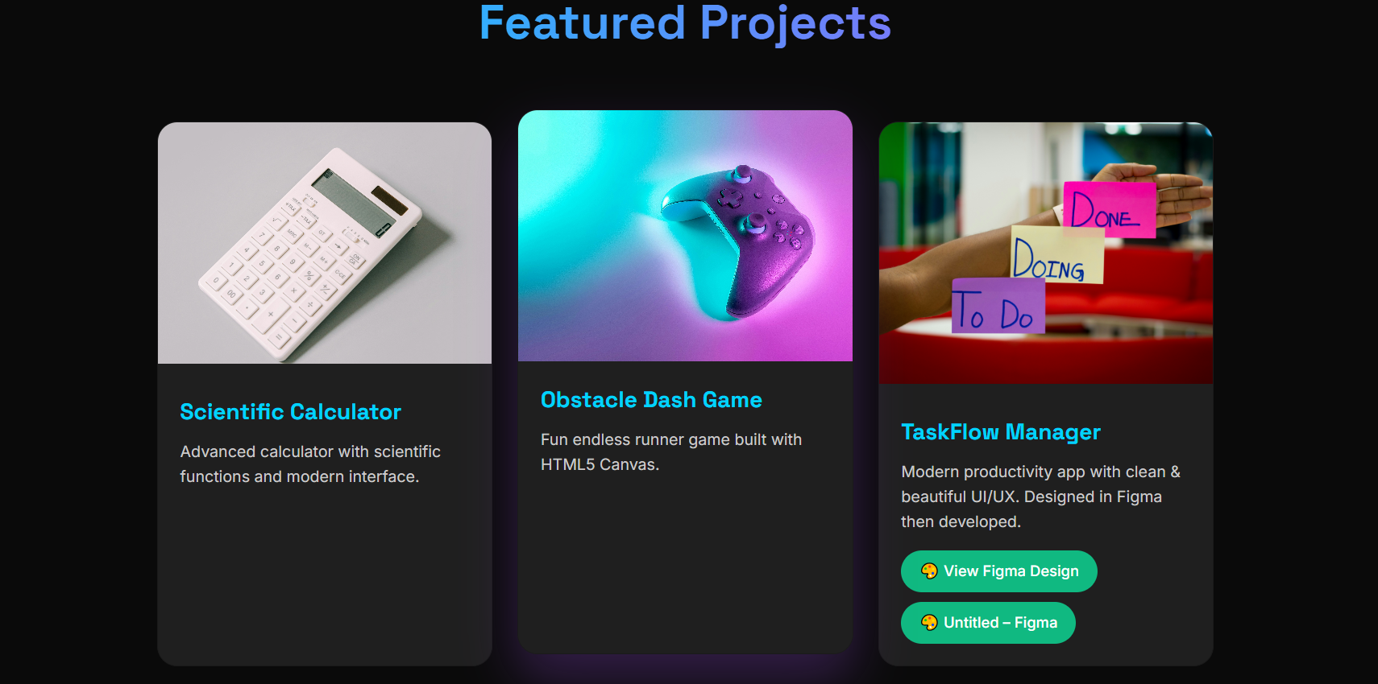


Day 08
Today marked the eighth day of development for my portfolio website. Following the completion of the Featured Projects section, my main focus for today was building the "Let's Connect" (Contact) section using HTML.
The main goal was to create a clean structure where visitors and recruiters can easily reach out to me, find my social links, download my resume, or send me a direct message through a contact form. This objective was fully completed today.

Contact Section (HTML Structure)
I built the structural framework for the contact section using clean, modern HTML tags:
- Section Container: Wrapped the entire content inside a main <section> element with id="contact" and class="section-alt", allowing for easy styling and direct navigation link jumping.
- Section Heading: Added an <h2> heading reading "Let's Connect" to clearly label the section.
- Social Links & CV Download: Created a dedicated container (.contact-links) with interactive link buttons (<a> tags):
  - A direct email link (:tharukatharidu7460@gmail.com) so visitors can launch their email app with one click.
  - Links to my professional LinkedIn and GitHub profiles (configured with target="_blank" so they open safely in new tabs).
  - A Download CV button using the download attribute (tharuka-cv.pdf) to let recruiters grab my resume instantly.
- Interactive Contact Form: Built a user-friendly form (<form id="contact-form">) wrapped inside a card container (.contact-form-wrap):
  - Added text inputs for Name and Email address.
  - Added a multi-line <textarea> (6 rows high) for typing detailed messages.
  - Used the required attribute on all fields so users cannot submit an empty form.
  - Added a primary "Send Message" submit button.

Day 09
Today marked the ninth day of development for my professional portfolio website. Following the HTML structure created on Day 8 for the "Let's Connect" (Contact) section, the main goal for Day 9 was to implement full CSS styling and JavaScript interactivity.
Using custom CSS properties and vanilla JavaScript, I transformed the static HTML markup into a polished, responsive, and highly interactive contact module. Key features added today include light/dark theme support, smooth scroll-reveal animations, custom button ripple effects, and dynamic form submission feedback. All objectives for this section are now fully complete.

Implementation Phase: Contact Section (CSS Styling & JavaScript)
CSS Styling Execution:
- Theme Variables & Light/Dark Mode: Defined comprehensive CSS custom properties in :root for dark mode and added full support for a light theme using [data-theme="light"]. Variables manage background colors, card backgrounds, input backgrounds, and text colors dynamically.
- Layout & Typography: Set up a clean section shell with a maximum content width of 1200px. Applied a linear gradient text mask (#00d4ff to #a855f7) to the section heading for visual consistency with the rest of the site.
- Social & CV Action Buttons: Styled the social links (.btn-social) into pill-shaped buttons with smooth hover elevations (translateY(-3px)). Styled the primary Download CV button with a vibrant background gradient fill.
- Form Aesthetics: Encapsulated the contact form in a centered card wrapper (700px max-width, 24px border radius). Custom-styled all input fields and textareas with rounded corners, subtle backgrounds, and full-width layout.
- Mobile Responsiveness: Added CSS Media Queries for screens below 600px width to adjust padding, decrease heading font sizes (2.1rem), and keep the form card comfortable on smaller viewports.
JavaScript Logic Execution:
- Scroll-Reveal Observer: Utilized the native IntersectionObserver API to monitor when the heading, social links, and form card scroll into view. When triggered, it attaches an .is-visible CSS class to create a smooth entrance animation.
- Ripple Click Micro-Interactions: Built a dynamic click listener (attachRipple) that calculates click coordinates and appends a scaling CSS circle (.ripple) to buttons, providing immediate tactile feedback upon clicking.
- Interactive Form Submission: Intercepted the form's submit event to prevent traditional page reloads (e.preventDefault()). Simulated an asynchronous network request by dynamically changing the button text from "Sending..." to "Message Sent ✓", clearing form inputs, and resetting the button state after a short delay.

Technical Challenges & Problem Solving

Challenge 1: Ensuring Accessibility for Users Sensitive to Motion
The Problem: Smooth scroll-reveal animations and scale effects can cause discomfort for visitors with vestibular motion disorders or those who have motion reduction enabled in their system settings.
The Solution: Integrated motion accessibility checks in both CSS and JavaScript. In JavaScript, I used window.matchMedia('(prefers-reduced-motion: reduce)') to automatically bypass the IntersectionObserver and display elements immediately. In CSS, I added a @media (prefers-reduced-motion: reduce) block to force full opacity and disable transforms.

Challenge 2: Providing Clear User Feedback Without a Backend Server
The Problem: Since an active backend email server (like EmailJS or Formspree) is not wired up yet, submitting the form could leave the user confused about whether their click worked.
The Solution: Created a smooth user-experience loop in JavaScript. Upon form submission, the submit button disables immediately and provides sequential step-by-step text feedback ("Sending..." -> "Message Sent ✓"). It then clears all form fields (form.reset()) and gracefully resets the button text after 2 seconds.

After add css,js for portpolio

